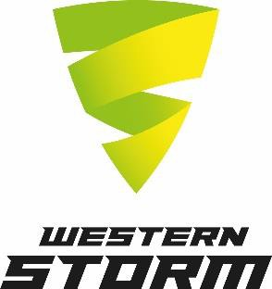

Application Pack Guidance

Dear colleague
Thank you for your interest in working with Western Storm Ltd. This guidance will enable you to fully understand our application process and complete your application comprehensively, offering you the best chance possible to be selected for the next stage.
A Safe and Inclusive Environment for All
We use fair and safer recruitment methods at Western Storm. We require an application form to be completed which enables us to make fair, unbiased selection decisions. The form allows us to a) remove applicants’ identifiable information during the shortlisting process b) assess all applicants based on their knowledge, skills and experience and c) gather important information required for safeguarding purposes. Therefore, we cannot accept CVs or covering letters, unless in very exceptional circumstances.
You will receive an application pack to enable you to apply for role. This consists of:
- The full job description and person specification
- Our application form
- A reference request consent form
- A proforma reference request letter
- An equality and diversity monitoring form
When completing the application form, we recommend you refer to the job description and person specification to demonstrate how you meet the essential criteria for the role. Include as much relevant, accurate detail as possible as we select candidates for the next stage based on their meeting these criteria.
The proforma reference request letter is just for your information, no action is required. This tells you what information we request from referees.
If you are happy with the information we request from referees, please complete and return the reference request consent form with your application. If offered the role, we will need to demonstrate to your referees that you have given us permission to obtain a reference from them.
We are committed to meet the aims and objectives set out in our Equality, Diversity and Inclusion policy. This includes developing our insight into the diversity and experiences of our current and potential colleagues, which will enable us to make informed decisions and improve everyone’s involvement with the Club. We kindly ask you to complete and return the equality and diversity monitoring form with your application. This is voluntary, you are under no obligation to do so, however, your cooperation will support us in deepening our understanding of the factors and issues which impact people in our community. The information provided will be kept confidential and will only be used for monitoring purposes. Under no circumstances will the information be used for recruitment or selection purposes, or in any manner not related to improving our ED&I approach.
If you need further advice, or require any reasonable adjustments to enable you to apply for roles or participate at any stage of the selection process, please let us know by emailing recruitment@westernstorm.co.uk

Please send completed application packs to the above email address, or post to Recruitment Department, SCCC, The Cooper Associates County Ground, St James Street, Taunton, TA1 1JT by the closing date.

We wish you the best of luck!

